Personal branding

Action Planning Workbook to create, promote and sustain your brand

- What are you passionate about?
_________________________________________________________________________________________________________________________________________________________________________________________________________________________________
- What are your values and beliefs?
_________________________________________________________________________________________________________________________________________________________________________________________________________________________________
- What motivates you?
_________________________________________________________________________________________________________________________________________________________________________________________________________________________________
- What makes you remarkable and unique?
_________________________________________________________________________________________________________________________________________________________________________________________________________________________________
- What are your goals (personal and professional)?
_________________________________________________________________________________________________________________________________________________________________________________________________________________________________
- What do you want to be known for?
______________________________________________________________________________________________________________________________________________________________________________________________________________________________________________________
- How do others perceive you?
______________________________________________________________________________________________________________________________________________________________________________________________________________________________________________________

Strong brand
What words describe a strong brand that you want to be known for? | What actions are you good at? | What do you want to be doing more of?

Poor brand
Identify any words that describe a poor brand that you need to work on? | What do you want to change?
Steps / tips to getting started:
Identify your strengths – This is your starting point!
- List professional attributes and characteristics (detail-oriented, effective communicator, etc.).
- Think about projects/responsibilities you’ve worked on in your career. Which ones have been the most successful?
- What specialized skills do your possess?

Determine your audience – while needing your brand to be genuine, think about WHO you are trying to influence and who you interact with … you may want to adjust for this
Create your personal brand –
- Network
- Volunteer for projects
- Offer expertise when you can
- Have an elevator speech
- Ask for feedback from others – ask people you trust and respect
- Check your online presence

Promote/sustain/improve – Make sure your ideas/intentions are consistent with your actions. Once you have worked to build a brand, don’t let it go unnoticed.
- Stay focused and deliver
- Demonstrate integrity by keeping your word
- Deliver results and outstanding work. Ask yourself the question, “Am I living this brand promise 100% of the time?”
- Maintain involvement, visibility and credibility
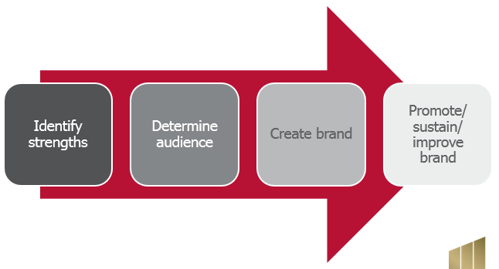
Action plan
What is your brand now?

What do you want to be known for?

What behaviors and actions do you need to establish to get there?

What’s one action to start today?

